Applied Payments Technology Pvt Ltd

https://www.appliedpaymentstech.com

PERFORMANCE Report – PRAVEGA

Contents

Document History 2

Glossary 2

1 Introduction 3

2 Jmeter Server – For Transaction Test From Jmeter 3

2.1 TEST ENVIRONMENT 3

2.2 jmeter Installation and Setup 3

3 Jmeter Test Plan Description 7

4 Test System Specifications 11

4.1 pravega test system specifications 11

4.1.1 Hardware Specification FOR Pravega Test System 11

4.1.2 Software Specification FOR Pravega Test System 11

4.2 jmeter system specifications 12

4.2.1 Hardware Specification FOR Jmeter Test System 12

4.2.2 Software Specification FOR Jmeter Test System 12

5 SAMPLE Test ScenaRIO 13

5.1 Test using JMETER 13

6 TestS CONDUCTED AND results OBTAINED at various tps 16

6.1 Test environment 1 16

6.2 Test environment 2 19

6.3 Test environment 3 20

6.4 Test environment 4 21

# Document History

|  |  |  |  |
| --- | --- | --- | --- |
| Version | Amendment Date | Reason for Amendment | Author |
| V1.0 | 01-02-2024 | Initial Draft | APT |

# Glossary

|  |  |
| --- | --- |
| Acronym | Full form |
| APT | Applied Payments Technology |

# 1 Introduction

This report describes the Benchmarking test procedures that are used to analyze the Performance, Capabilities, and behavior of Pravega Switch under different scenarios.

# 2 Jmeter Server – For Transaction Test From Jmeter

## 2.1 TEST ENVIRONMENT

JMETER to be deployed on a separate system.

Below listed are the pre-requisites application versions which should be installed on the system prior to the installation of JMETER.

|  |  |
| --- | --- |
| Software  Name and Version | |
| Operating System | Microsoft Windows 11 |
| Open JDK/Oracle Java | Version 8 |
| JRE | Java 1.8 (1.6 or above) |
|  |  |

## 2.2 jmeter Installation and Setup

* Download and extract the latest version of Apache JMeter in the windows system.

Link to download the latest version: https://dlcdn.apache.org//jmeter/binaries/apache-jmeter-5.6.2.zip

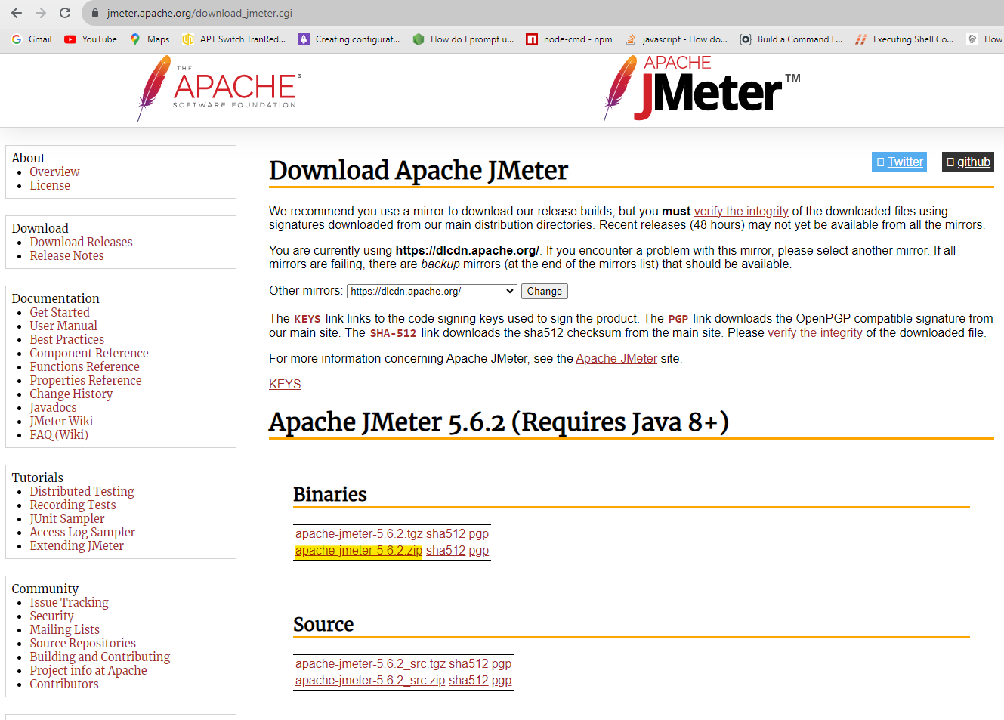

* Unzip the Apache JMeter zip file and locate the jar file inside the “bin” directory.

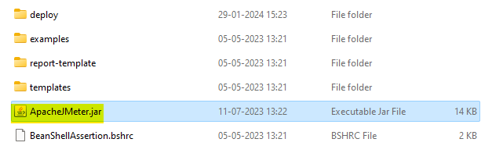

* Double click on the ApacheJmeter.jar file and open the JMeter application

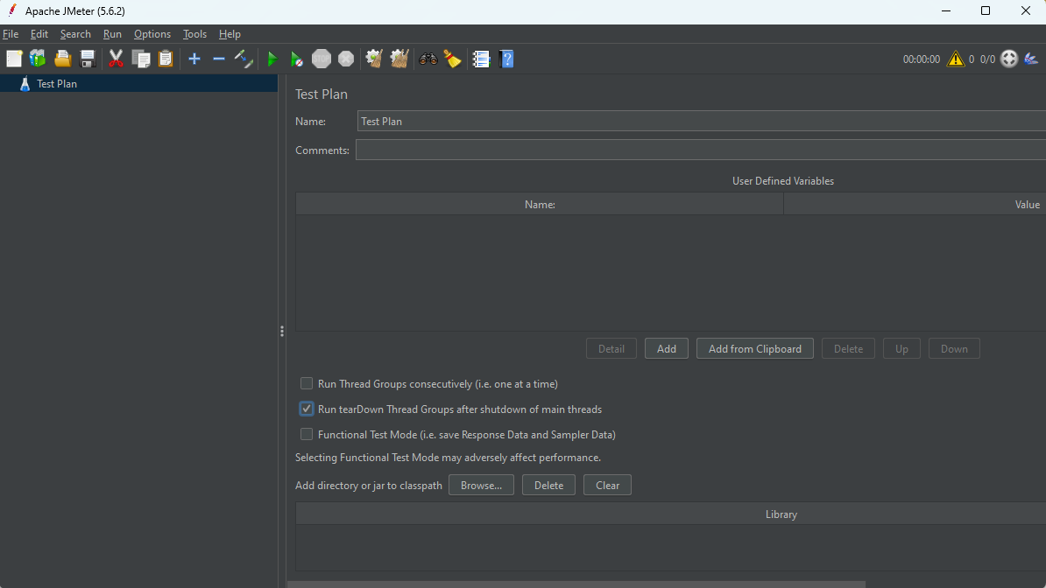

* Open the existing test plan by navigating through the flow mentioned below,

File > Open > Select the required “.jmx file” > Open

(The ISO8583_transaction_Testsampler.jmx file will be sent along with this document)

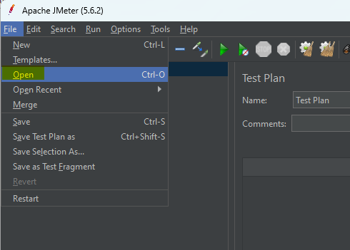

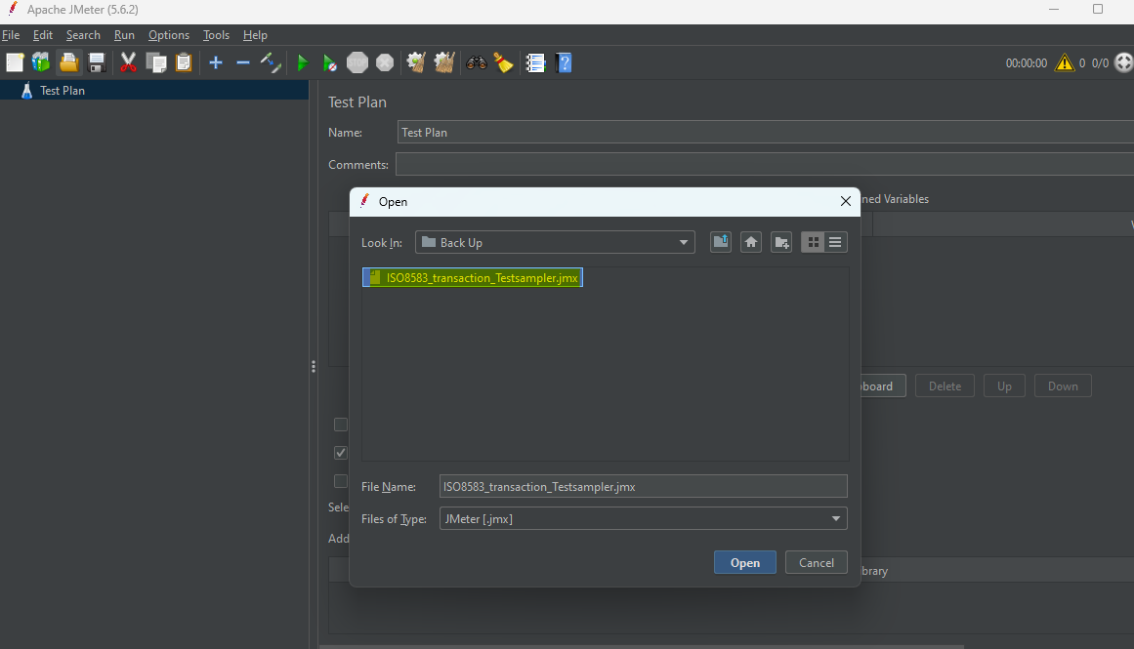

* Configure the users and rampup values based on the different test cases. Here we have configured 10000 users and a rampup time of 1000 seconds which will create a transaction speed of 10TPS.

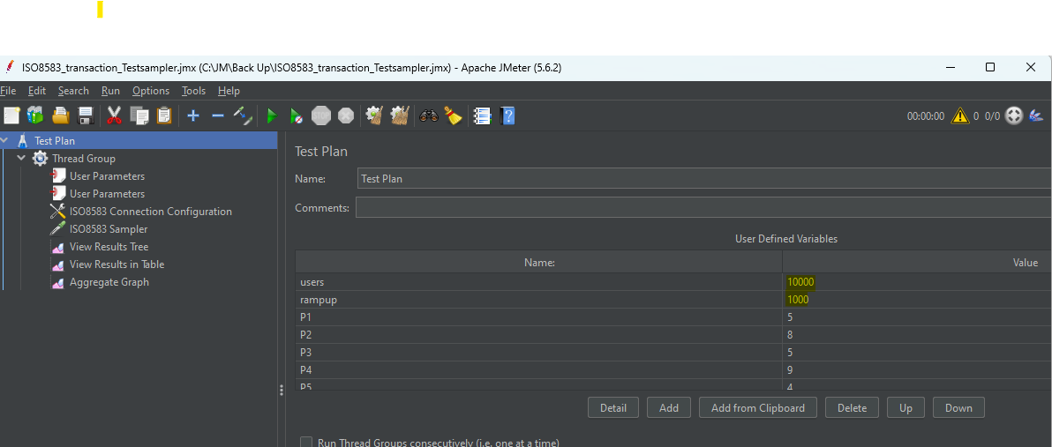

* Configure the IP and port to send the transactions (ISO Adapter server port).It can be configured inside the ISO8583 Connection Configuration of the thread group.

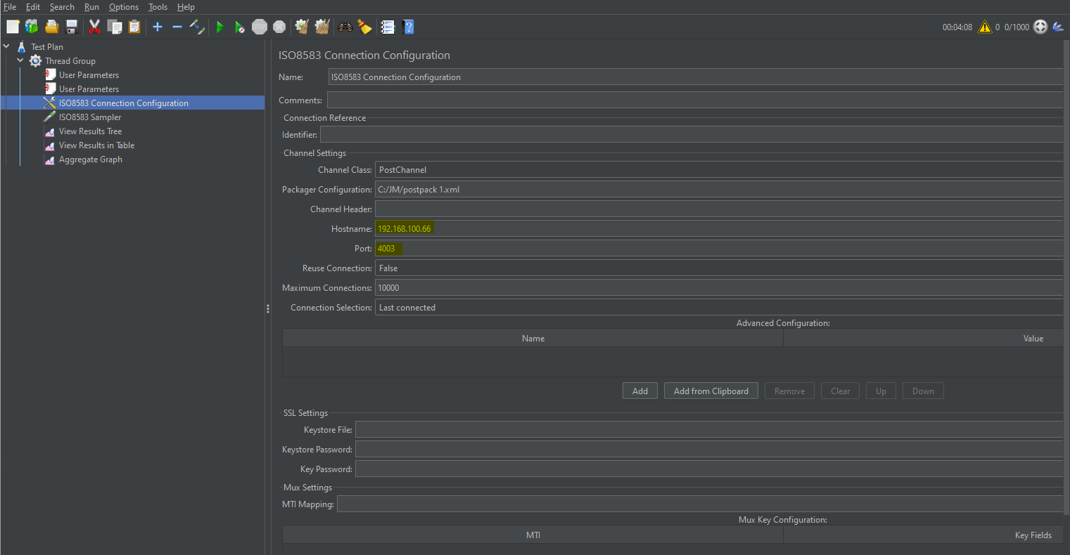

* Choose the packager configuration xml file by browsing into saved the file location. (The postpack.xml file will be sent along with this document)

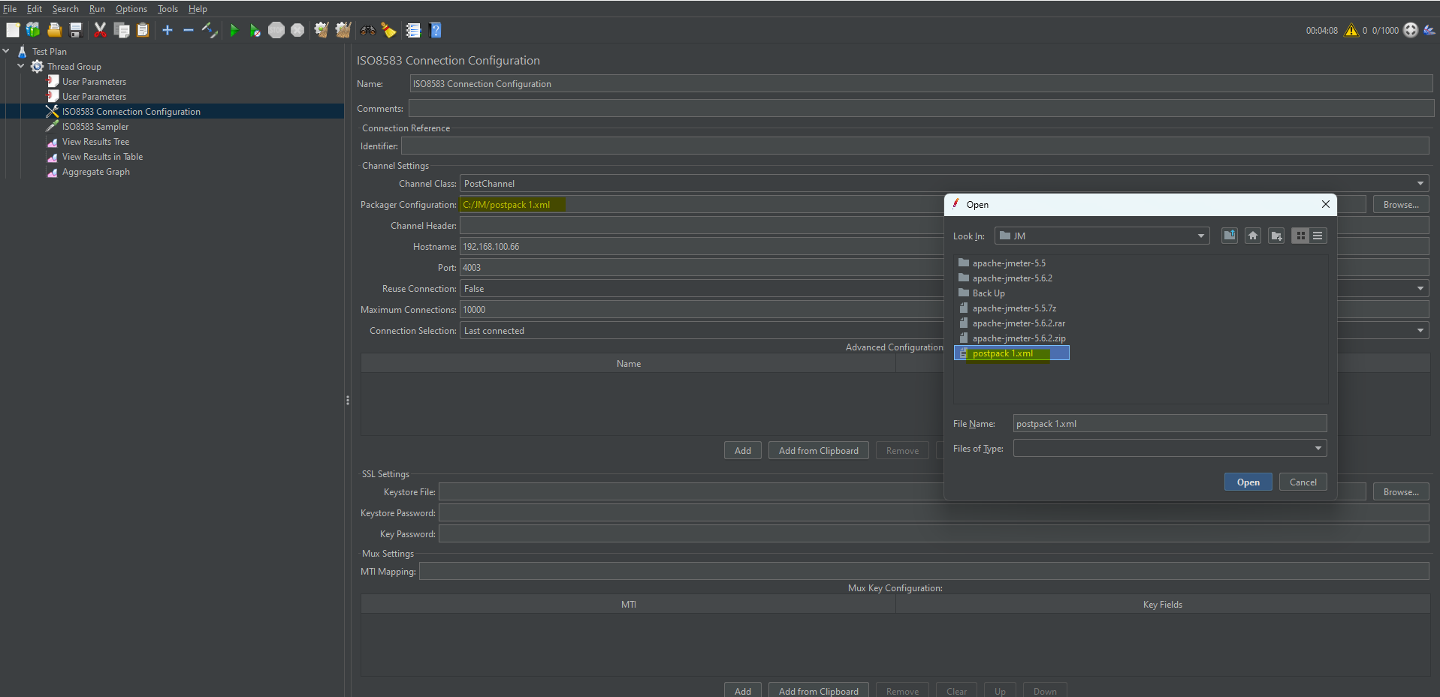

The postpack.xml file is an XML file with the required ‘isofields’ configured in it.

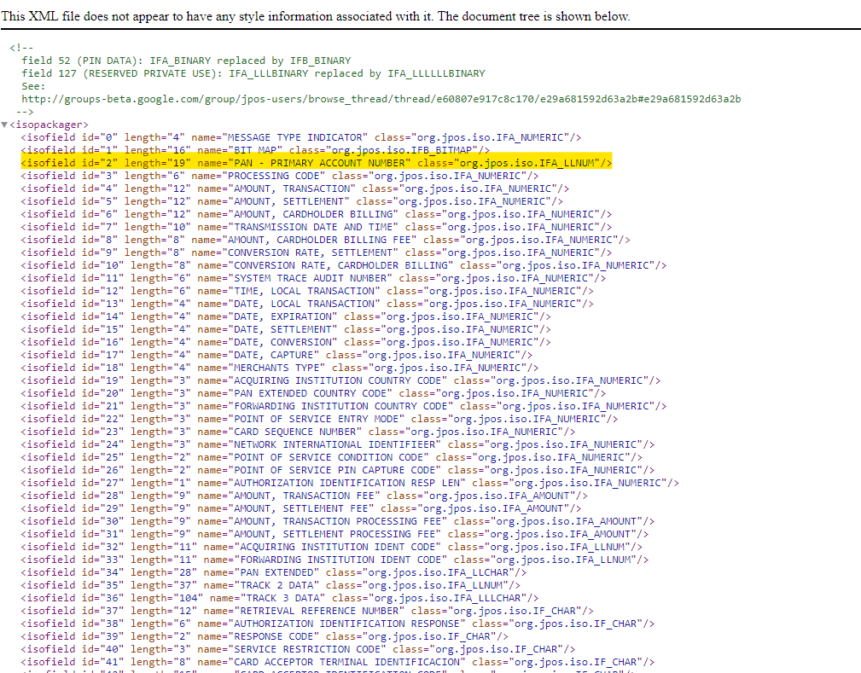

# 3 Jmeter Test Plan Description

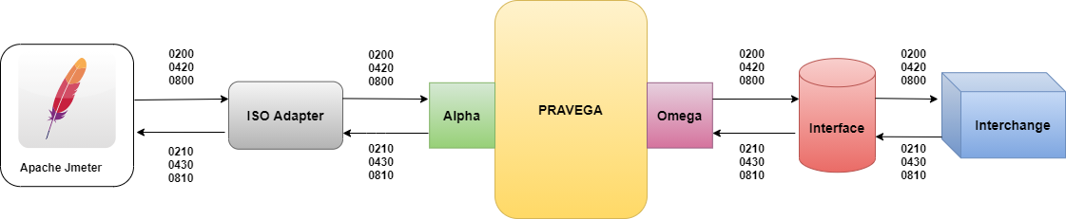

The Transactions can be triggered from JMeter to the Pravega - ISOAdapter server interchanges. In this test plan, the incoming binary data of an ISO transaction (Transactions coming from Postbridge to Pravega) is plotted in a ISO8583 sampler under a thread group in JMeter and the samples can be triggered by adjusting the users and ramp-up period values in the thread group.

* **Test plan** – A test plan can be visualized as your JMeter script for running tests. A test plan consists of test elements such as thread groups, logic controllers, sample-generating controllers, listeners, timers, assertions, and configuration elements.
* **User parameter** – User Parameters are used to define values for the variables to be used in the Samplers.

Variables are configured inside the user parameters and the variables are mapped to a function called Random variables.

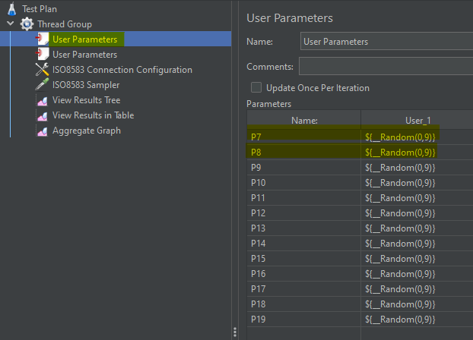

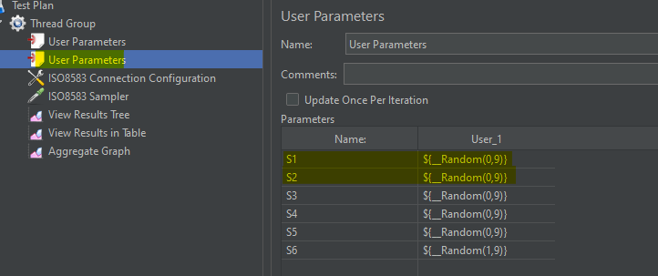

Constant parameters are assigned in the Test Plan in the section user defined variables. Assigned the below Alphabets to the constant parameters so that the values can be changed at any time by changing the values. The variables are then called in the binary data of the ISO8583 sampler.

“P” - PAN

“S” - STAN,

* **Thread Group** – As the name implies, thread group represents the group of threads JMeter will use during the test. Thread group elements are the beginning points of any test plan. The controls provided by a thread group allow you to:
  + Set the number of threads.
  + Set the ramp-up period.
  + Set the number of times to execute the test.
  + Configure the name of the test.
  + Number of threads (the number of users you are testing).
  + Ramp-up time (how much time you want to allow the Thread Group to go from 0 to 3 users).
  + Loop count (How many times the test should be looped).
  + Scheduler checkbox (The checkbox at the bottom of the Thread Group panel is used to enable/disable extra fields in which you can enter the duration of test, the startup delay, the start, and end times of the run).
  + After creating the Thread Group, create ISO8085 sampler under the thread Group.
* **ISO8583 sampler – The ISO8583 Sampler opens a TCP/IP connection to the specified server. It then sends the text and waits for a response.**

ISO8583 sampler have the binary data of a sample transaction configured in it. In the binary data, part of the PAN from the 6th position to 19th position & STAN is configured with variables and the variables are mapped to the random variables function in JMeter. At the time of test, the variables will have a random value in it and every transaction will be unique provided certain scenarios are ignored.

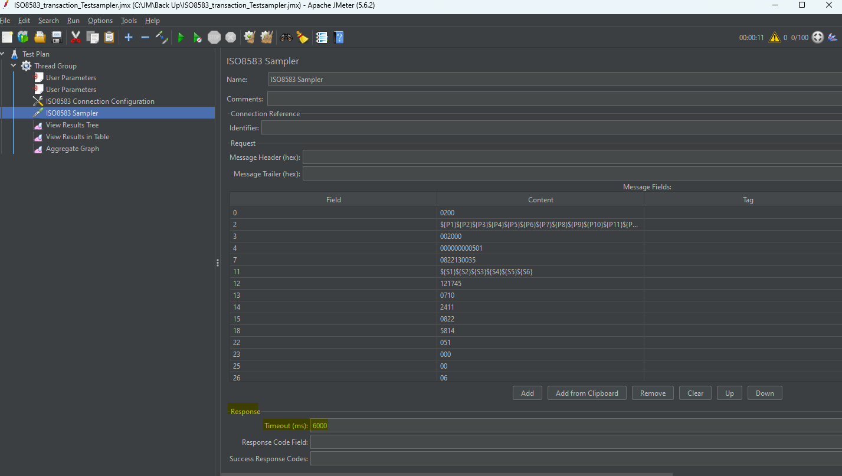

* View Result tree –View Result tree is a listener configured under the thread group to see the transactions sent from JMeter and responses received to JMeter from Pravega.

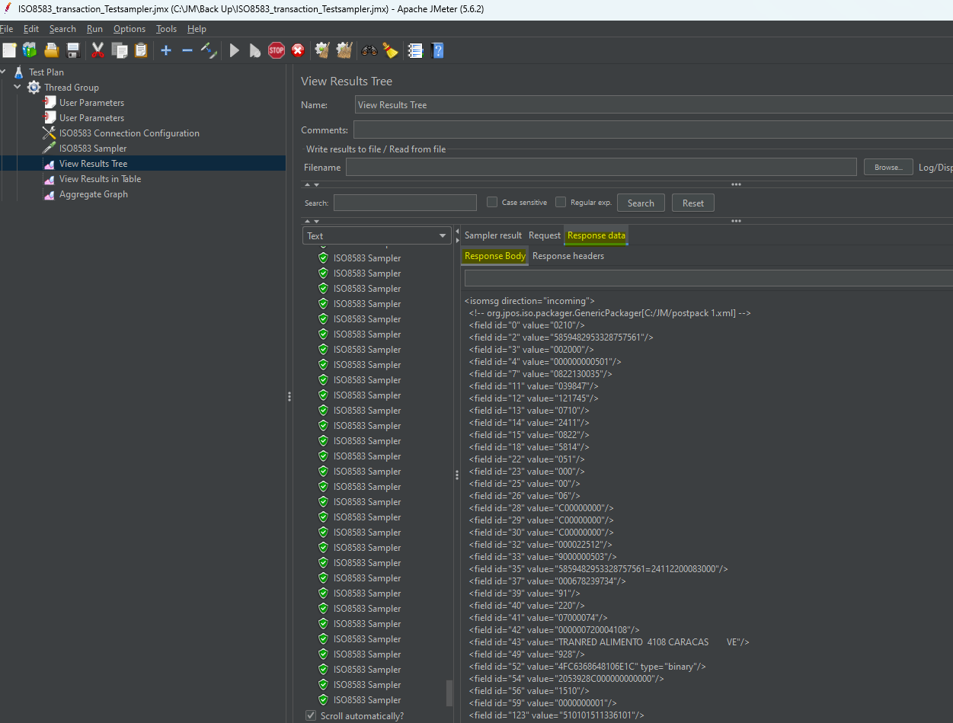

# 4 Test System Specifications

This section describes the specifications and application prerequisites of the system used for the benchmarking test.

4.1 pravega test system specifications

Below mentioned are the configuration of the Ubuntu system where Pravega Switch was deployed and executed for benchmarking test.

### 4.1.1 Hardware Specification FOR Pravega Test System

|  |  |
| --- | --- |
| Specification | Details |
| CPU | 64-bit – 6n |
| RAM | 12GB |
| Storage | 200 GB |
| Disk | 1 |

### 4.1.2 Software Specification FOR Pravega Test System

|  |  |
| --- | --- |
| Software  Name and Version | |
| Operating System | Ubuntu 20.04 Desktop version |
| Open JDK/Oracle Java | Version 8 |
| JRE | Java 1.8 |
| Apache Tomcat | Version 8.5 |
| Database | MS SQL Server 2019 Standard version |
| Nodejs | Version 12.x.x |
| Custom Library files for connection to be added on to Apache Tomcat 8.5 lib folder (will be provided by APT) | log4j-1.2-api-2.7.jar  log4j-api-2.7.jar  log4j-core-2.7.jar  log4j-slf4j-impl-2.7.jar  log4j-web-2.7.jar  org.json_1.0.0.v201011060100.jar  mssql-jdbc-6.2.2.jre8.jar |
| Redis server | Redis - version 5.x |
| Git | Version 2.x |

4.2 jmeter system specifications

The Apache JMeter is an open-source, purely Java-based software. The software is used to perform performance testing, functional testing, and load testing of web applications. It is used to test load scenarios and thereby measuring performance of the application or website.

Here is the configuration of Windows system where the JMeter is executed.

### 4.2.1 Hardware Specification FOR Jmeter Test System

|  |  |
| --- | --- |
| Specification | Details |
| CPU | 1.60GHz |
| RAM | 8.0 GB |
| Storage | 500 GB |
| Disk | 1 |

### 4.2.2 Software Specification FOR Jmeter Test System

|  |  |
| --- | --- |
| Software  Name and Version | |
| Operating System | Windows 11 |
| Open JDK/Oracle Java | Version 8 |
| JRE | Java 1.8 |
| Apache Tomcat | Version 8.5 |
| JMeter | Version 5.6 |
| Git | Version 2.x |

# 5 SAMPLE Test ScenaRIO

The below-given tests from the environment (JMeter) are conducted to analyze the performance of the Pravega Switch. This test includes transactional tests with different TPS for different durations. Benchmarking test procedures that are used to analyze the Performance, Capabilities, and behavior of pravega switch under different scenarios.

## 5.1 Test using JMETER

Load the .jmx file in JMeter and update the base configuration (IP and Port of Pravega to connect) accordingly.

Change the “users” and “rampup” values to test transactions in different TPS of different durations.

For example,

Test Case 1: Transactions will fire to one ISO Adapter interchange.

users = 1000

rampup = 100s

Effective transactions per second (TPS) = 10 TPS

Effective Test Duration = 100 Seconds

Pravega timeout:30000ms

JMeter timeout:60000ms

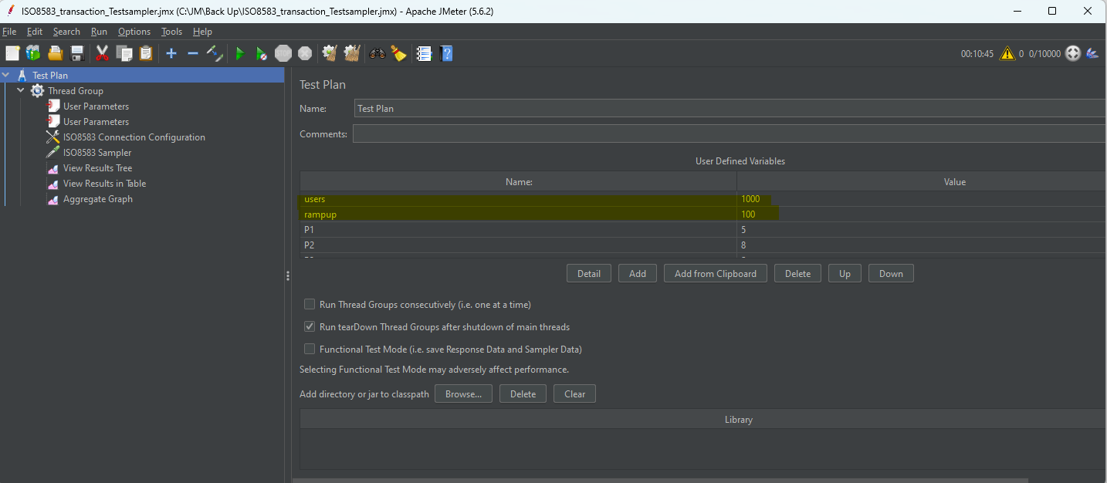

**Test Result:**

1000 transaction messages were sent from JMETER and 723 responses are reached to JMETER.

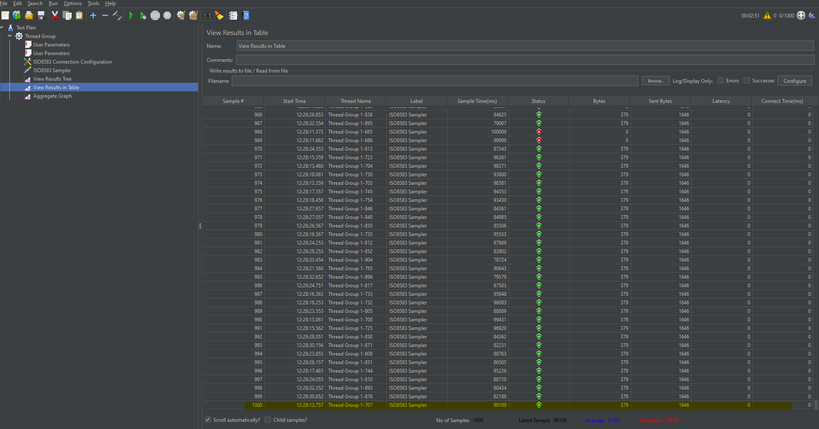

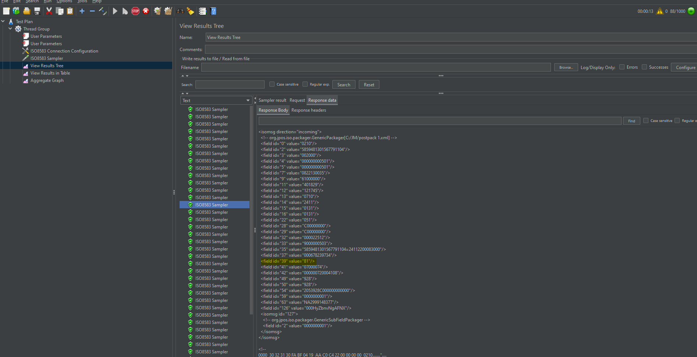

At the same time1000 transactions (1000 requests and 1000response messages each) are stored in DATABASE from pravega switch without any failure.

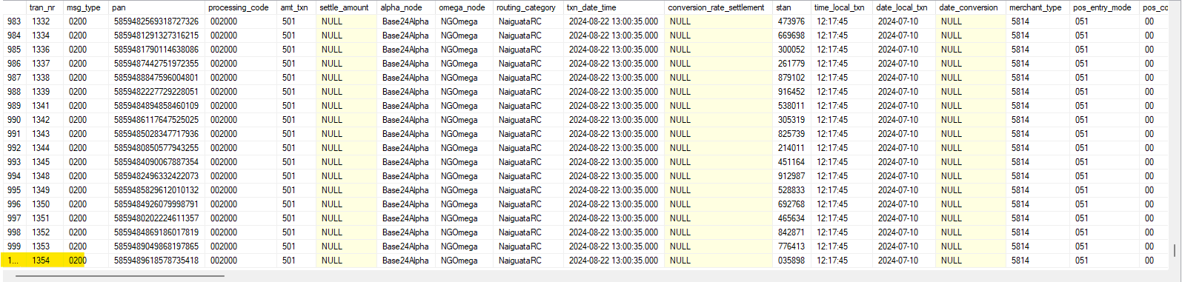

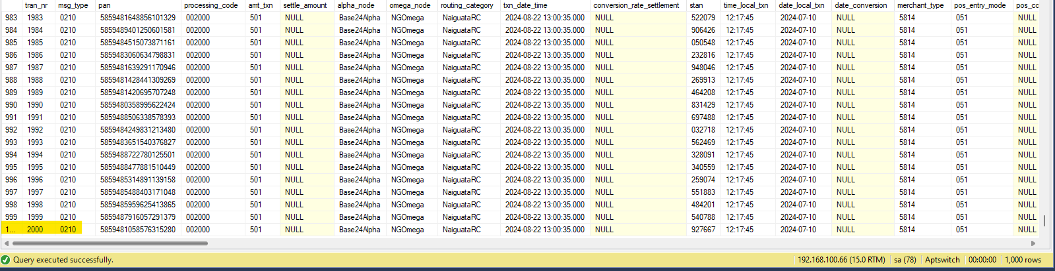

# 6 TestS CONDUCTED AND results OBTAINED at various tps

### 6.1 Test environment 1

Pravega Code: pravegaswitch-Pravega_PosApp_pending_issues (250124)

Database specification in the current implementation:

|  |  |
| --- | --- |
| Microsoft SQL Server Developer (64-bit) |  |
| Operating system | Ubuntu (20.04) |
| Platform | Linux |
| Version | 15.0.4261.1 |
| Memory | 19051 MB |
| Processors | 6 |
| Minimum Server Memory | 1024 MB |
| Maximum Server Memory | 14000 MB |
| Index creation Memory (Dynamic Memory) | 0KB |
| Minimum Memory per Query | 1024 KB |
| Query Wait | -1 |
| Remote Query Time out | 600 sec |

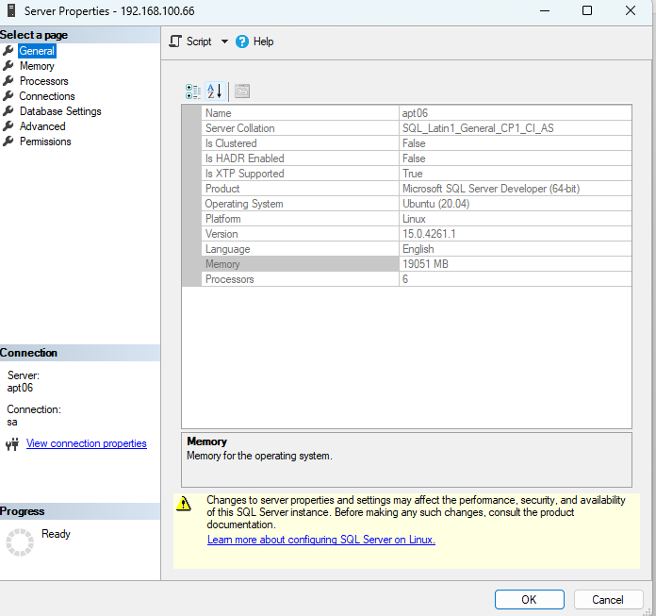

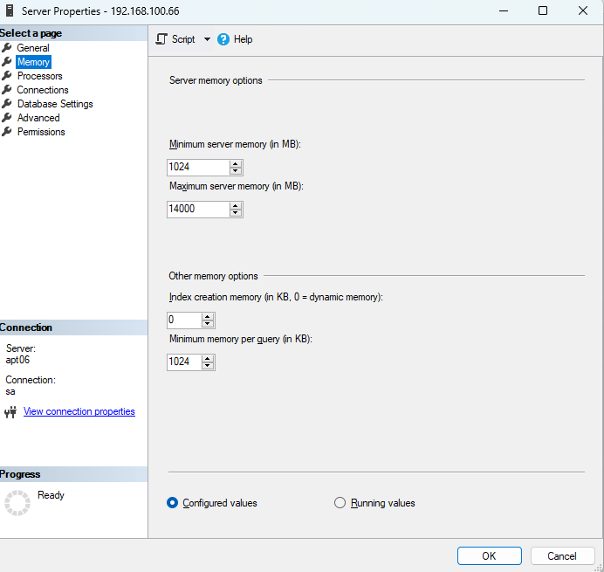

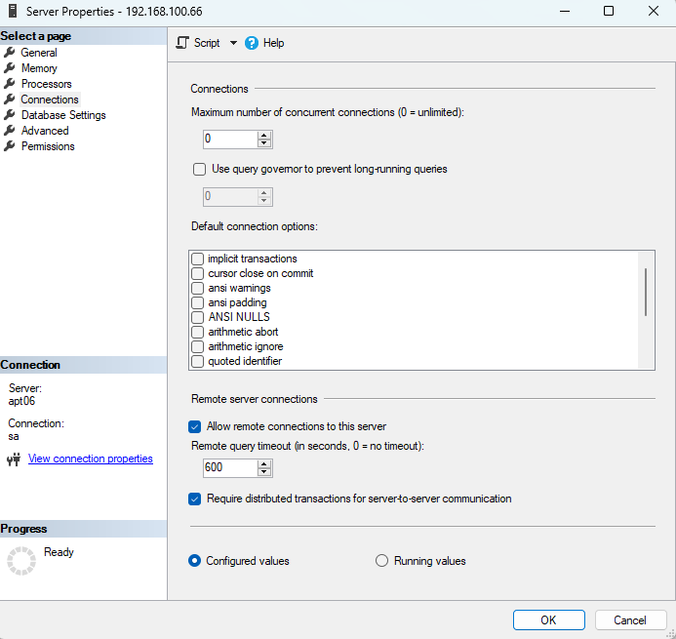

TESTING AT 20 TPS WITH DEFAULT DB MEMORY:

Results:

|  |  |  |  |  |  |  |  |  |  |  |  |  |  |
| --- | --- | --- | --- | --- | --- | --- | --- | --- | --- | --- | --- | --- | --- |
| **LOGGER AND TRACE FUNCTION STATUS IN PRAVEGA** | **JMETER** | | | | **TRANSACTIONS  STORED IN DATABASE** | | **RESPONSE TIME OUTS** | | **RESPONSE_CODE** | | | | |
| ON or OFF | USERS (CONCURRENT REQUESTS FROM JMeter) | RAMPUP TIME (TIME TAKEN FOR JMETER TO START ALL USERS/REQUEST THREADS) | TPS FROM JMeter=USERS/RAMPUP TIME | NO. OF RESPONSE RECEIVED IN JMeter | REQUESTS (200) STORED IN DATABASE | RESPONSE (210) STORED IN DATABASE | RESPONSE TIMEOUT IN PRAVEGA (OMEGA NODE) | RESPONSE TIMEOUT IN JMeter (ISO 8583 SAMPLER) | 91 | 81 | 80 | 63 | 00' |
| ON | 1000 | 50 | 20 | 106 | 998 | 214 | 30000ms | 60000ms | Nil | 28 | 61 | 125 | Nil |
|  |
|  |
|  |
|  |
| OFF | 1000 | 50 | 20 | 309 | 1000 | 309 | 30000ms | 60000ms | Nil | 58 | 66 | 185 | Nil |  |
|  |
|  |
|  |
|  |
| ON | 6000 | 300 | 20 | 73 | 5535 | 284 | 30000ms | 60000ms | Nil | 74 | 49 | 161 | Nil |  |
|  |
|  |
|  |
|  |
| OFF | 6000 | 300 | 20 | 1053 | 5989 | 1136 | 30000ms | 60000ms | Nil | 240 | 174 | 722 | Nil |  |
|  |
|  |
|  |
|  |

**TEST FINDINGS ON TESTING IN ENVIRONMENT 1**

1000 txn-request from JMeter: -

* Data base stored 998 txn-request messages and 214 txn-response messages while logger function enabled.
* Data base stored 1000 txn-request messages and 309 txn-response messages while logger function disabled.
* It is observed that the ‘91’ response code is not obtained in any of the ‘210’ messages.

6000 txn-request from JMeter: -

* Data base stored 5535 txn-request messages and 284 txn-response messages while logger function enabled.
* Data base stored 5989 txn-request messages and 1136 txn-response messages while logger function disabled.
* It is observed that the ‘91’ response code is not obtained in any of the ‘210’ messages.

### 6.2 Test environment 2

Pravega Code: performance_Test_010224

Database specification:

|  |  |
| --- | --- |
| Microsoft SQL Server Developer (64-bit) |  |
| Operating system | Ubuntu (20.04) |
| Platform | Linux |
| Version | 15.0.4261.1 |
| Memory | 19051 MB |
| Processors | 6 |
| Minimum Server Memory | 500 MB |
| Maximum Server Memory | 5000 MB |
| Index creation Memory (Dynamic Memory) | 0KB |
| Minimum Memory per Query | 1024 KB |
| Query Wait | -1 |
| Remote Query Time out | 600 sec |

TESTING AT 20 TPS BY REDUSING THE DB MEMORY:

Results:

|  |  |  |  |  |  |  |  |  |  |  |  |  |  |
| --- | --- | --- | --- | --- | --- | --- | --- | --- | --- | --- | --- | --- | --- |
| **LOGGER AND TRACE FUNCTION STATUS IN PRAVEGA** | **JMETER** | | | | **TRANSACTIONS  STORED IN DATABASE** | | **RESPONSE TIME OUTS** | | **RESPONSE_CODE** | | | | |
| ON or OFF | USERS (CONCURRENT REQUESTS FROM JMeter) | RAMPUP TIME (TIME TAKEN FOR JMETER TO START ALL USERS/REQUEST THREADS) | TPS FROM JMeter=USERS/RAMPUP TIME | NO. OF RESPONSE RECEIVED IN JMeter | REQUESTS (200) STORED IN DATABASE | RESPONSE (210) STORED IN DATABASE | RESPONSE TIMEOUT IN PRAVEGA (OMEGA NODE) | RESPONSE TIMEOUT IN JMeter (ISO 8583 SAMPLER) | 91 | 81 | 80 | 63 | 00 |
| OFF | 6000 | 300 | 20 | 1020 | 5993 | 1064 | 30000ms | 60000ms | Nil | 216 | 144 | 704 | Nil |
|  |
|  |
|  |
|  |

### 6.3 Test environment 3

Pravega Code: performance_Test_010224

Database specification:

|  |  |
| --- | --- |
| Microsoft SQL Server Developer (64-bit) |  |
| Operating system | Ubuntu (20.04) |
| Platform | Linux |
| Version | 15.0.4261.1 |
| Memory | 19051 MB |
| Processors | 6 |
| Minimum Server Memory | 2048 MB |
| Maximum Server Memory | 14000 MB |
| Index creation Memory (Dynamic Memory) | 0KB |
| Minimum Memory per Query | 1024 KB |
| Query Wait | -1 |
| Remote Query Time out | 600 sec |

TESTING AT 20 TPS BY INCREASING THE DB MEMORY:

Results:

|  |  |  |  |  |  |  |  |  |  |  |  |  |  |
| --- | --- | --- | --- | --- | --- | --- | --- | --- | --- | --- | --- | --- | --- |
| **LOGGER AND TRACE FUNCTION STATUS IN PRAVEGA** | **JMETER** | | | | **TRANSACTIONS  STORED IN DATABASE** | | **RESPONSE TIME OUTS** | | **RESPONSE_CODE** | | | | |
| ON or OFF | USERS (CONCURRENT REQUESTS FROM JMeter) | RAMPUP TIME (TIME TAKEN FOR JMETER TO START ALL USERS/REQUEST THREADS) | TPS FROM JMeter=USERS/RAMPUP TIME | NO. OF RESPONSE RECEIVED IN JMeter | REQUESTS (200) STORED IN DATABASE | RESPONSE (210) STORED IN DATABASE | RESPONSE TIMEOUT IN PRAVEGA (OMEGA NODE) | RESPONSE TIMEOUT IN JMeter (ISO 8583 SAMPLER) | 91 | 81 | 80 | 63 | 00 |
| OFF | 6000 | 300 | 20 | 794 | 5995 | 895 | 30000ms | 60000ms | Nil | 160 | 94 | 641 | Nil |
|  |
|  |
|  |
|  |

### 6.4 Test environment 4

Pravega Code: performance_Test_010224

Database specification:

|  |  |
| --- | --- |
| Microsoft SQL Server Developer (64-bit) |  |
| Operating system | Ubuntu (20.04) |
| Platform | Linux |
| Version | 15.0.4261.1 |
| Memory | 19051 MB |
| Processors | 6 |
| Minimum Server Memory | 2048 MB |
| Maximum Server Memory | 20000 MB |
| Index creation Memory (Dynamic Memory) | 0KB |
| Minimum Memory per Query | 1024 KB |
| Query Wait | -1 |
| Remote Query Time out | 600 sec |

TESTING AT 20 TPS BY INCREASING THE DB MEMORY:

Results:

|  |  |  |  |  |  |  |  |  |  |  |  |  |  |
| --- | --- | --- | --- | --- | --- | --- | --- | --- | --- | --- | --- | --- | --- |
| **LOGGER AND TRACE FUNCTION STATUS IN PRAVEGA** | **JMETER** | | | | **TRANSACTIONS  STORED IN DATABASE** | | **RESPONSE TIME OUTS** | | **RESPONSE_CODE** | | | | |
| ON or OFF | USERS (CONCURRENT REQUESTS FROM JMeter) | RAMPUP TIME (TIME TAKEN FOR JMETER TO START ALL USERS/REQUEST THREADS) | TPS FROM JMeter=USERS/RAMPUP TIME | NO. OF RESPONSE RECEIVED IN JMeter | REQUESTS (200) STORED IN DATABASE | RESPONSE (210) STORED IN DATABASE | RESPONSE TIMEOUT IN PRAVEGA (OMEGA NODE) | RESPONSE TIMEOUT IN JMeter (ISO 8583 SAMPLER) | 91 | 81 | 80 | 63 | 00 |
| OFF | 6000 | 300 | 20 | 816 | 5995 | 917 | 30000ms | 60000ms | Nil | 167 | 98 | 652 |  |
|  |
|  |
|  |
|  |

**TEST FINDINGS ON TESTING IN ENVIRONMENT2,3&4:**

In environment 2 data base stored 5993 txn-request messages and 1064 txn-response messages.

In environment 3 data base stored 5993 txn-request messages and 895 txn-response messages.

In environment 4 data base stored 5995 txn-request messages and 917 txn-response messages.

A slight deviation only obtained in the test result while testing on environment 2,3 & 4

I It is observed that the ‘91’ response code is not obtained in any of the ‘210’ messages.